

State of Vermont
Agency of Human Services
Department of Vermont Health Access (DVHA)
10 East Allen Street 2nd Floor
Winooski, Vermont 05404

Customer Support

Business Process Manual

Appeals
An appeal is the review of an eligibility determination or a decision to deny, terminate or reduce services by a qualified and unbiased health care professional. An appeal provides an opportunity for evaluation of case documents, verification of the accuracy of submitted documents, or for the appellant to submit updated info or to provide further explanation of previously submitted documents. If the appeal outcome is unsatisfactory, the party can request a fair hearing.

Summary Diagram

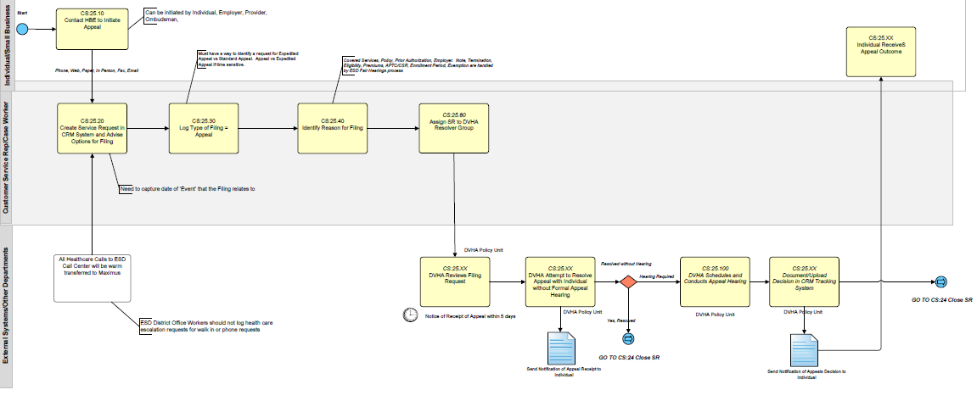
Figure 1. Summary diagram for appeal process. (Changes: 1) every complaint will start as an appeal and be escalated as a fair hearing if necessary, 2) all SHOP appeals will flow through the Small Business Support Unit.)

Steps

On the Portal
Appeals can be initiated by submitting a request with the “Appeal” Request Type, or from the Appeal button on the Eligibilty Determination page in the application process flow. The following provides an example of the User navigation through the Appeal Flow.

- The User may appeal determination results from the Health Benefits Exchange Eligibility screen (below), or by submitting a service request (see Section XX).

Figure XX. Application—Health Benefits Exchange Eligibility screen (individual view)

Figure XX. Employee Application—Health Benefits Eligibility screen (SHOP employee view)

Figure XX. SHOP Application—SHOP Employer Eligibility screen

- Review the information on the Submitting an Appeal page and click Next.

Figure XX. Appeal—Submitting an Appeal screen

- Select the benefit to appeal and click Next.

Figure XX. Appeal—Program I am Appealing screen

Figure XX. Employee Appeal—Program I am Appealing screen

- Enter a description of the appeal and upload supporting documentation with the Upload button.

Figure XX. Appeal—Submit an Appeal screen

- On the Upload Document pop-up, click Browse to locate supporting documentation, enter information on the document in the Comments box, and click Submit.

Figure XX. Appeal—Upload Document pop-up

- Use the checkboxes, Delete All Selected Link, and Edit or Delete buttons to edit or delete uploaded documentation. Click Submit to continue.

Figure XX. Appeal—Submit an Appeal screen

- The appeal is confirmed. Click My Messages, My Account, or My Requests links to return to the My Account pages.

Figure XX. Appeals—Appeal Confirmation screen

- The submitted appeal and related information are shown on the My Requests tab in My Account. Click Withdraw to withdraw the appeal. Click the appeal’s ID to review the appeal information.

Figure XX. My Account—My Requests Tab

- Caseworker comments on the appeal are listed in the Comments section, and the Status and Resolved fields track the progress of the appeal. Click Upload New Documentation to add a new supporting document, or enter comments and click Respond to send comments to caseworkers.

Figure XX. My Account—Request screen

In the CRM
- CSR creates a Service Request in the CRM (type: Complaint; subtype: Appeal).
- CSR identifies and records the reason for filing.
- CSR assigns the Service Request to AOPS/SBSU.
- AOPS/SBSU reviews the Service Request.
- AOPS/SBSU schedules the Appeal.
- AOPS/SBSU conducts the Appeal.
- AOPS/SBSU resolves the Appeal.
- AOPS/SBSU closes the Service Request with the appropriate resolution type (Appeal Granted/Appeal Denied).

Revision History

Version number | Implemented by | Revision date | Approved by | Approval date | Description
1.0 | Jessica Miller | 5/3/13 |  |  | Initial Draft

Sources

Cassandra Gekas and Nicole Weidman. Personal communication with Jessica Miller. 5/3/2013
Oracle 3.2.1 User Guide
Meeting: Business Process Mapping II: grievances, appeals, fair hearings & fraud. In attendance: Tena Perrelli (organizer), Sonia Tagliento, Sean Brown, Pam Daley, Cindy Chaffee, Nicole Weidman, Jackie Baker, Rob Tornai, Jessica Miller 4/18/2013
Cassandra Gekas. Personal communication with Tena Perrelli. 4/29/2013

Additional Information

Link to Quick Sheet, Conventions, Glossary/Acronym list

